Design and Verification of a Parameterized Synchronous FIFO Using Verilog HDL and Xilinx Vivado
1. Project Overview
This project focuses on the RTL design, functional verification, synthesis, and implementation of a parameterized synchronous First-In First-Out (FIFO) memory using Verilog HDL. A FIFO is a memory buffer that stores data in sequential order. The first data written into the FIFO is the first data read out. The design uses a single clock for both read and write operations and supports configurable data width and FIFO depth.
2. Design Specifications
Parameter | Value
Design type | Synchronous FIFO
HDL | Verilog HDL
Data width | 32 bits
FIFO depth | 8 locations
Total storage capacity | 256 bits
Pointer width | 4 bits
Clock | Single clock
Reset | Synchronous reset in the current RTL
Design tool | Xilinx Vivado 2026.1
Target FPGA part | Kintex-7 `xc7k70tfbv676-1`

3. Block diagram
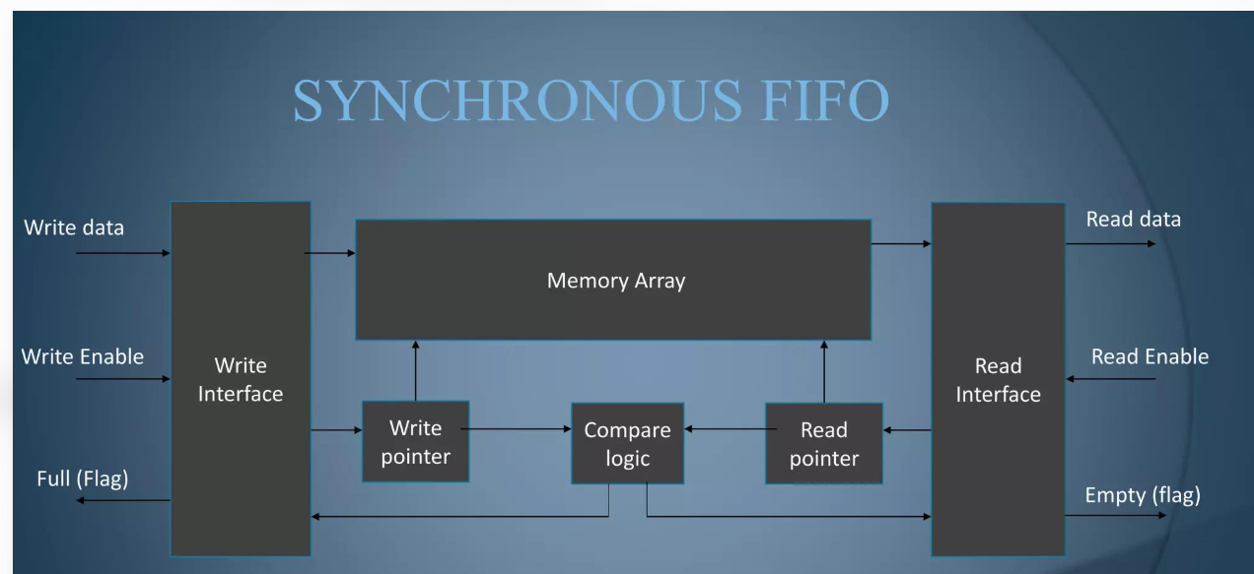

4. Features
- Parameterized data width and FIFO depth.
- Independent read and write control signals.
- Single-clock synchronous operation.
- Write and read pointer management.
- Full and empty status generation.
- Protection against writing when the FIFO is full.
- Protection against reading when the FIFO is empty.
- Memory-based data storage.
- Functional verification using a Verilog testbench.
5. FIFO Operation
- Write operation:
- Data is written into the FIFO when chip select (`cs`) and write enable (`we`) are asserted.
- A write is accepted only when the FIFO is not full.
- The write pointer advances after an accepted write.
- Read operation:
- Data is read when chip select (`cs`) and read enable (`re`) are asserted.
- A read is accepted only when the FIFO is not empty.
- The read pointer advances after an accepted read.
- Status flags:
- Empty condition: The FIFO is empty when the read pointer and write pointer are equal, indicating that no data is available to read.
empty = (w_ptr == r_ptr)
- Full condition: The FIFO is full when the lower pointer bits are equal, but the most significant bits of the read and write pointers are different, indicating that the write pointer has completed one additional wraparound.These conditions assume the standard extra-MSB pointer scheme and a FIFO depth of 8 (power-of-two depth).
full = (w_ptr[3] != r_ptr[3]) && (w_ptr[2:0] == r_ptr[2:0])
6. RTL Design
The design is implemented using:
- FIFO memory array.
- Write pointer and read pointer.
- Full and empty flag logic.
- Separate clocked read and write processes.
The pointer width includes an additional most significant bit (MSB) to distinguish pointer wraparound and support full/empty condition.

7. Functional Verification
A Verilog testbench was developed to verify FIFO functionality. Functional simulation was performed using ModelSim and Xilinx Vivado.Verification scenarios include:
- Reset operation.
- Writing data into the FIFO.
- Reading stored data.
- Sequential write and read operations.
- FIFO full condition.
- FIFO empty condition.
- Prevention of writes when full.
- Prevention of reads when empty.
- Pointer advancement and wraparound.
waveform screenshot showing reset, write, read, full, and empty operations:
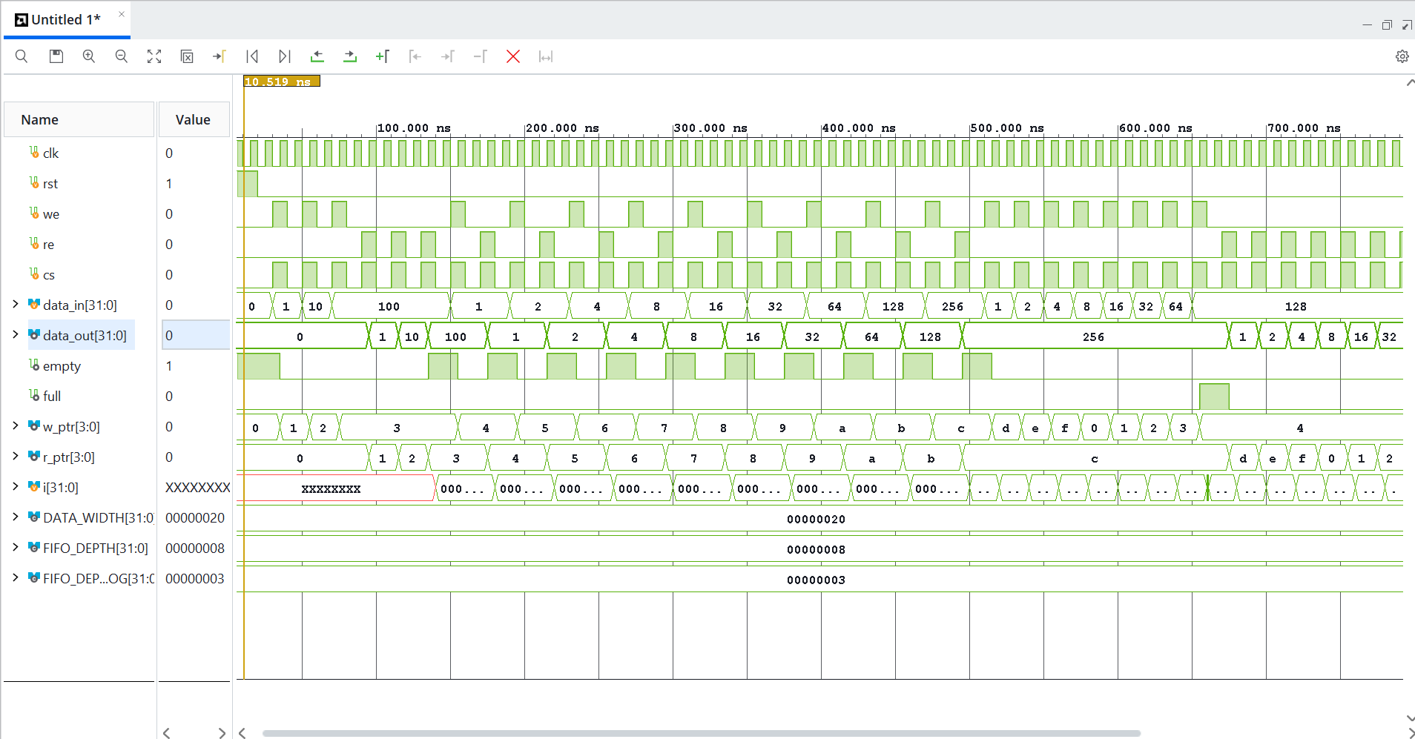
8.RTL analysis:
Screenshot showing the schematic diagram of design:
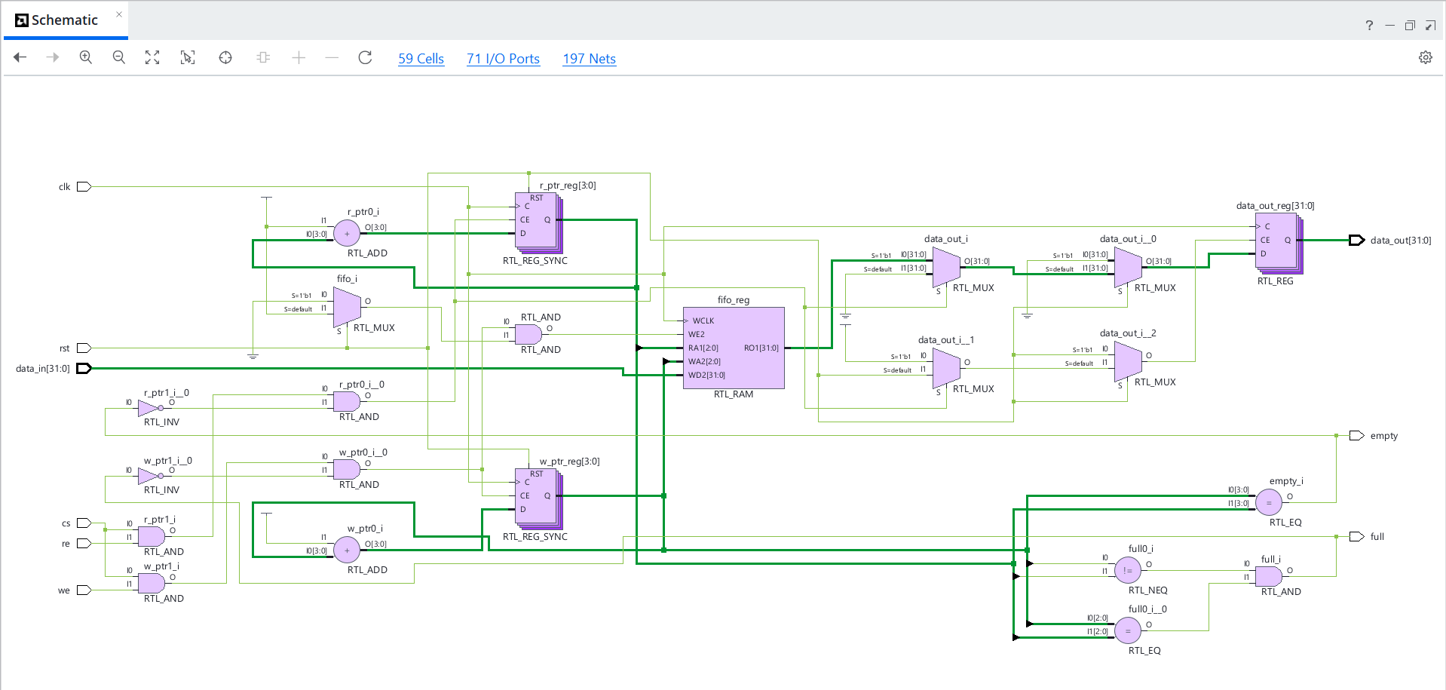
9. Synthesis and Implementation
The RTL design was synthesized and implemented using Xilinx Vivado 2026.1.
Reported synthesis utilization:
Resource | Reported value
LUTs | 66
Flip-Flops | 40
I/O ports | 71

Vivado also reported LUT-based distributed memory inference for the FIFO storage.
Timing analysis:
The latest reported timing summary was:
Timing parameter | Result
WNS | -1.576 ns
TNS | -24.253 ns
WHS | +0.061 ns
WPWS | +4.090 ns
Failing setup endpoints | 34

The negative WNS indicates that the design did not meet the setup timing requirements under the constraints used for this implementation. The timing constraints include assumed external input/output delays for this learning exercise.
Screenshort showing the project summary with reports of synthesis, implementation, utilization and timing analysis.
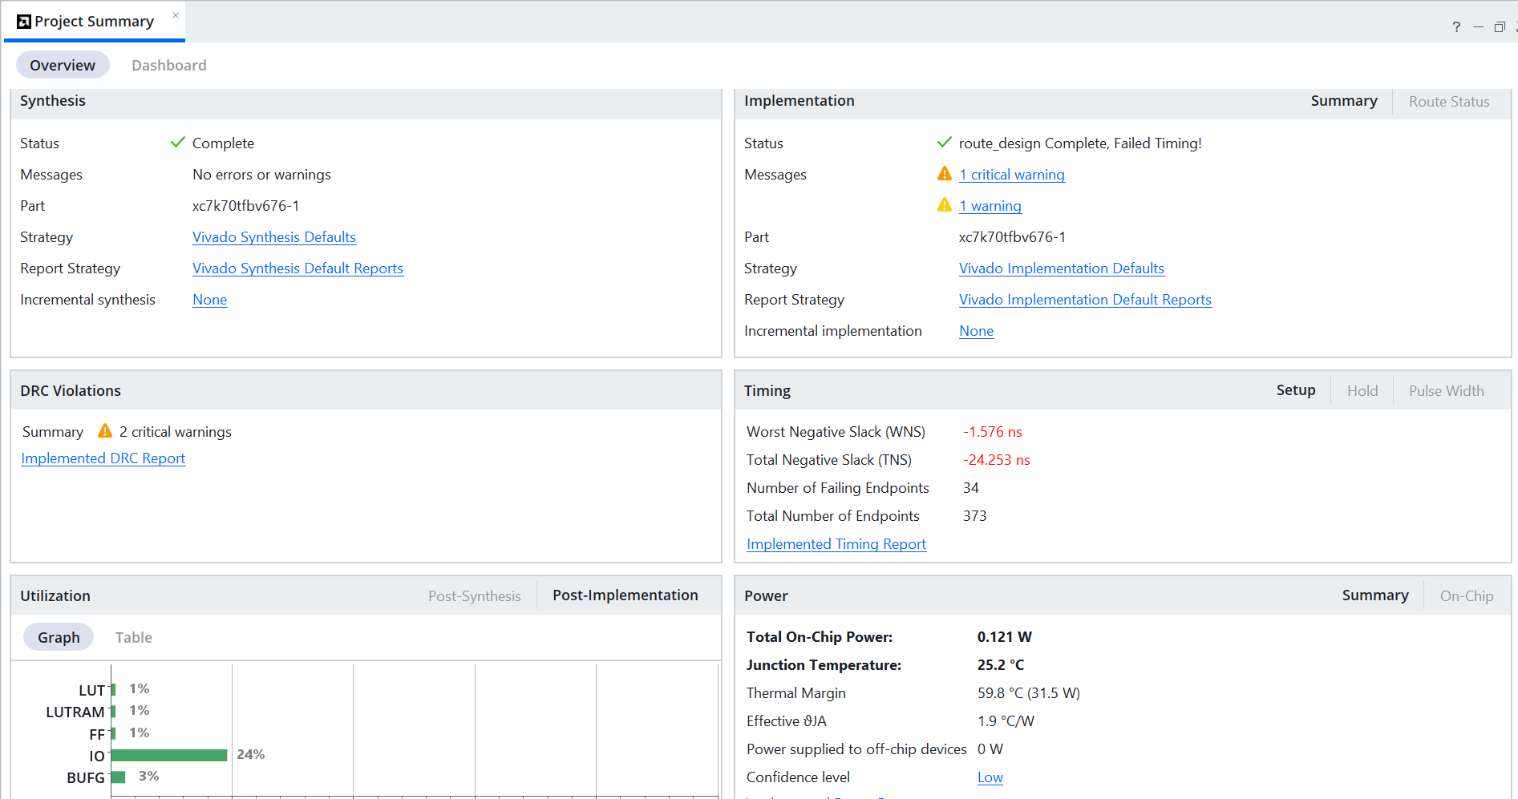
10. Bitstream Generation:
Bitstream generation was completed successfully in Vivado. Since no physical FPGA development board was available, the UCIO-1 and NSTD-1 DRC checks were downgraded to warnings for this learning exercise.
Therefore:
- Physical pin assignments were not validated.
- I/O standards were not validated against an actual board.
- The generated bitstream was not programmed or tested on physical FPGA hardware.
screenshot showing the completion of bit stream generation:
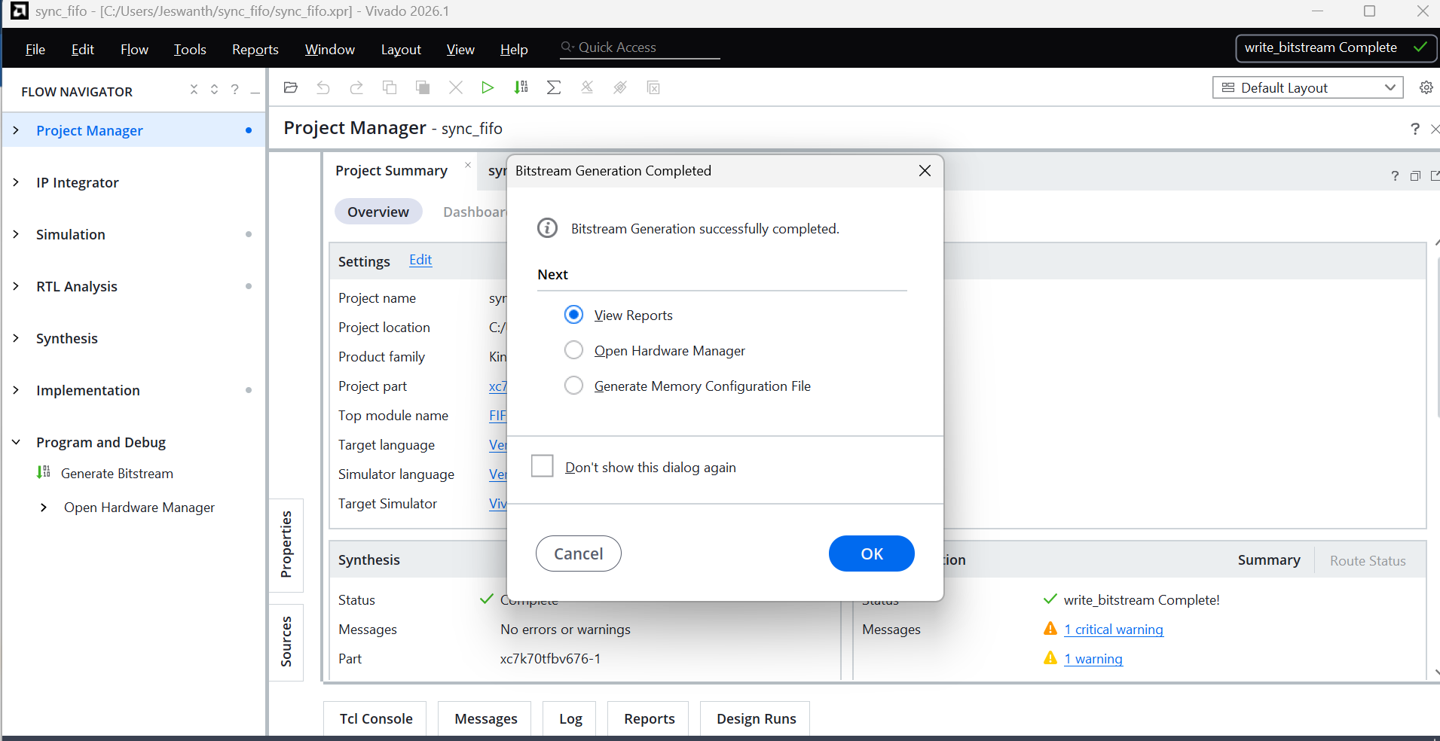
11. Tools and Technologies:
- Verilog HDL
- ModelSim 20.1
- Xilinx Vivado 2026.1
- RTL Simulation
- FPGA Synthesis and Implementation
- Timing Analysis
12. Learning Outcomes:
- Understanding synchronous FIFO architecture.
- RTL coding using Verilog HDL.
- Pointer management and wraparound logic.
- Full and empty flag generation.
- Functional verification using testbenches.
- RTL synthesis and FPGA implementation flow.
- Resource utilization and timing report analysis.
13. Project Type: Self-Learning / Personal VLSI Project
14. Implementation Status: RTL simulation, synthesis, implementation, and bitstream generation completed.

